GNSO POLICY DEVELOPMENT UPDATE

ISSUE

Translation and Transliteration of Contact Information Policy Development Process

DEFINITON
Translation: translation of text into another language; transliteration: writing a word by using the closest corresponding letters of a different alphabet

UPCOMING IMPORTANT DATES: The WG has completed its review of the comments that were submitted in response to its Initial Report. Members are now working on completing the Final Report, targeting its publication for ICANN53.

SUMMARY
The Policy Development Process (PDP) on the translation and transliteration had its inaugural meeting on 19 December 2013 and since then the Group is discussing the following issues:

1. Whether it is desirable to translate contact information to a single common language or transliterate contact information to a single common script.
2. Who should decide which party(s) should bear the burden of translating contact information to a single common language or transliterating contact information to a single common script.

In its Initial Report, the Working Group does not recommend to mandate the translation/transliteration of contact information data. However, as there was no unanimity in the Working Group with regards to this recommendation, the Group asks the Community explicitly to supply in their public comments additional arguments for/against translation of contact information to help inform deliberations in the run up to its Final Report. A majority of comments supported the existing preliminary recommendation not to mandate translation/transliteration of contact information.

ENGAGEMENT OPPORTUNITY STATUS

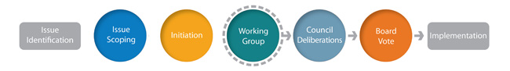

The Working Group is currently completing its Final Report, remaining open for anyone to join its deliberations. The Group aims to conclude its work by ICANN 53.

ADDITIONAL INFORMATION:
Initial Report: http://gnso.icann.org/en/issues/gtlds/transliteration-contact-initial-15dec14-en.pdf
Webinar Recording on Initial Report: https://icann.adobeconnect.com/p2lzjk3zy0f/
Report of Public Comment: https://www.icann.org/en/system/files/files/report-comments-transliteration-contact-initial-19feb15-en.pdf
Wiki Space: https://community.icann.org/x/FTR-Ag

