**GNSO POLICY DEVELOPMENT UPDATE**

ISSUE

Privacy & Proxy Services Accreditation Issues in relation to the 2013 Registrar Accreditation Agreement and the development of a Privacy & Proxy Services Accreditation Program by ICANN

UPCOMING IMPORTANT DATES

Publication of Initial Report for public comment – estimated May 2015.

SUMMARY

The Registrar Accreditation Agreement (RAA) is the contract that governs the relationship between ICANN and its accredited registrars (a directory of accredited registrars can be found at <http://www.internic.net/regist.html>). Its provisions also may have impacts on registrants and other third parties involved in the domain name system. In June 2013, the ICANN Board approved a new 2013 RAA (the provisions of which can be found at <http://www.icann.org/en/resources/registrars/raa/approved-with-specs-27jun13-en.pdf>).

In initiating negotiations for the 2013 RAA between ICANN and the Registrars Stakeholder Group in October 2011, the ICANN Board had also requested an Issue Report from the GNSO that, upon the conclusion of the RAA negotiations, would start a GNSO Policy Development Process (PDP) to address remaining issues not dealt with in the RAA negotiations that would be suited to a PDP. The GNSO Council approved the charter for this effort at its meeting on 31 October 2013 and a Working Group was formed.

The WG has developed preliminary recommendations for a number of the charter questions it was tasked to address (see <https://community.icann.org/x/ihLRAg>) and aims to produce an Initial Report for public comment before the June 2015 ICANN Meeting in Buenos Aires.

GAC ENGAGEMENT OPPORTUNITY STATUS

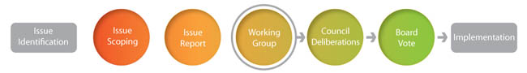

The WG sought input early on from all Supporting Organizations and Advisory Committees (including the GAC) on its chartered issues. It welcomes input from the GAC on its preliminary recommendations and, when published, its Initial Report.

ADDITIONAL INFORMATION:

WG Charter: <http://gnso.icann.org/en/drafts/raa-pp-charter-22oct13-en.pdf>

WG Workspace: <https://community.icann.org/x/9iCfAg>